Name: Borigi Sabareesh

Gmail:saba.tkl123@gmail.com

**ASSIGNMENT SOLUTIONS**

1)Install Jupyter notebook and run the first program and share the screenshot of the output.

SOURCE CODE:

s=input("Enter Your Name:")

print("Hello ",s + "!")

print("welcome To Python World")

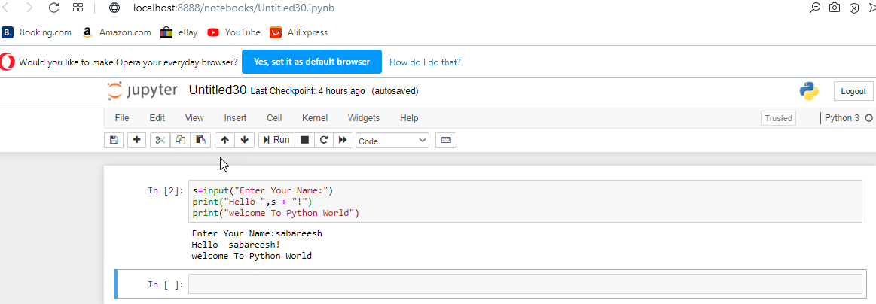

2) Write a program which will find all such numbers which are divisible by 7 but are not a multiple of 5, between 2000 and 3200 (both included). The numbers obtained should be printed in acomma-separated sequence on a single line.

Source code:

for i in range(2000,3201):

if i%7==0 and i%5!=0:

print(i,end=",")

Output:

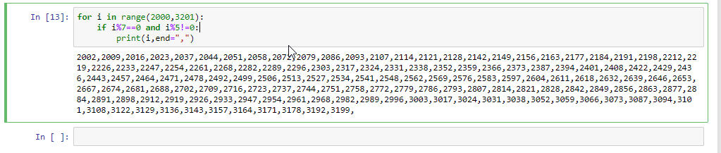

3) Write a Python program to accept the user's first and last name and then getting them printed in the reverse order with a space between first name and last name.

Source code:

f=input("enter first name:")

l=input("enter last name:")

print(f[::-1]+" "+l[::-1])

Output:

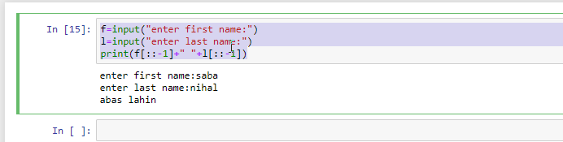

~~4)~~ Write a Python program to find the volume of a sphere with diameter 12 cm. Formula: V=4/3 * π * r3

SOURCE CODE:

D=int(input("enter the diameter of sphere:"))

V=(4/3)*(22/7)*(((D/2)**3))

print(V)

OUTPUT:

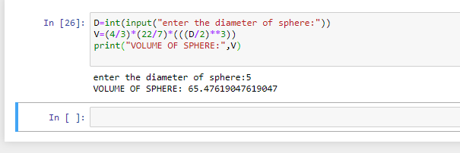

TASK 2:

1.Write a program which accepts a sequence of comma-separated numbers from console and generate a list.

Source code:

N=input()

l=[]

for i in N:

if i!=',':

l.append(int(i))

else:

continue

print(l)

Output:

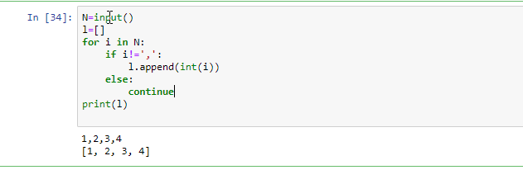

2)

Create the below pattern using nested for loop in Python.

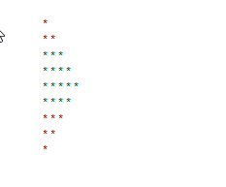

Source code:

for i in range(1,6):

for j in range(i):

print("*",end="")

print("\n")

for i in range(6,1,-1):

for j in range(i):

print("*",end="")

print("\n")

Output:

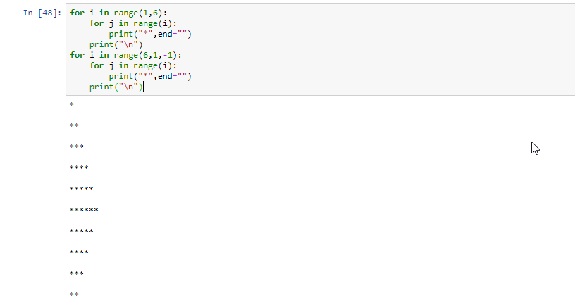

3). Write a Python program to reverse a word after accepting the input from the user.

Sample Output:

Input word: AcadGild

Output: dilGdacA

Source code:

n=input()

print(n[::-1])

output:

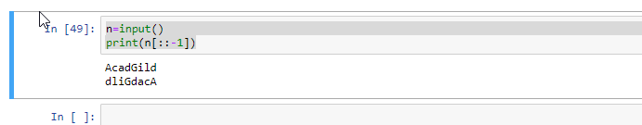

4.Write a Python Program to print the given string in the format specified in the ​sample output.

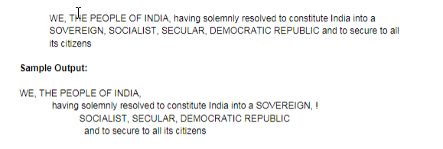

SOURCE CODE:

print('''WE, THE PEOPLE OF INDIA,

having solemnly resolved to constitute India into a SOVEREIGN,I

SOCIALIST, SECULAR, DEMOCRATIC REPUBLIC

and to secure to all its citizens''')

OTPUT:

